1. INTRODUCTION
   1. Purpose

This document provides developers, tester, QAs a complete and comprehensive description of both the functional requirement and non-functional requirements of the 3S system. Developers base on this document to develop the system, and testers base on this to assure the quality of the output system. Project manager base on this document to create schedule and assign task to team members.

* 1. Scope

This document defines all functional and non-functional requirements for 3S system. Beside, creating the diagrams to helps developers be easy to understand in Software Architecture Design stage.

* 1. Definition and Acronyms
  2. Overview

Section 2 of this document provides overall information of the project, while excluding the specific requirements. Instead, it provides the background for those requirements, which are defined in Section 3

Section 3 describes all the requirements in detail, including functional requirements and non-functional requirements. Each function is described based on the following format:

* Use Case: the detailed description of all use cases
* Screen: The mockup/prototype of the screen which describes the workflow of the Use Case

1. OVERVIEW DESCRIPTION
   1. Product perspective

The below rich picture describes all perspectives of product:

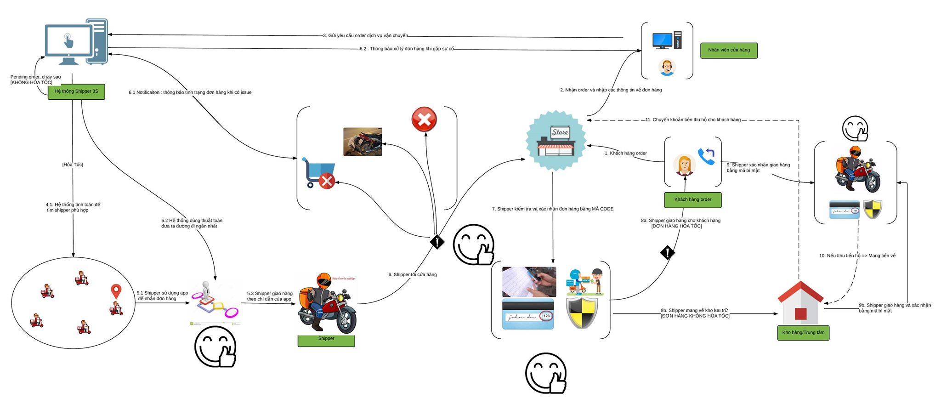

The product includes 3 types:

* Web Service: This is linking between Web App with Mobile App. Beside, executing logic to response data (JSON) for clients through API.
* Web App: This is an app that supports for 2 types of user
  + Admin: Manage (Shipper, Store), Resolve Issue, Control & Tracking Orders, …
  + Store: Create Order, Find Shipper, Confirm Code, Rate, Send Feedback, …
* Mobile App: This is an app that supports for shipper’s business
  + Shipper: Receive/Reject order, find short path, Send issues message, …
  1. Product functions

Refer to Section 3

* 1. User charactistics

There are three main actors that system support:

* Store: This system towards the stores which have demand to transport goods to clients but don’t have a team of professional shipper.
* Shipper: They are transformers that enjoy system to get income.
* Administrator: They use all functions that supported by system to manage activities of system.
  1. Constraint
* All products of system have to meets the deadline
* All processes and related documents have to observe procedure of FPT
  1. Assumption and dependencies
* Receive the guidance and good support of teacher
* No one of member got sick in the software development process
* In the development process, no device got fail
* Evert report meets the deadline
* Team member do not conflict and get high responsibility in the working process
  1. Activity Diagram

This diagram describes the procedure of order

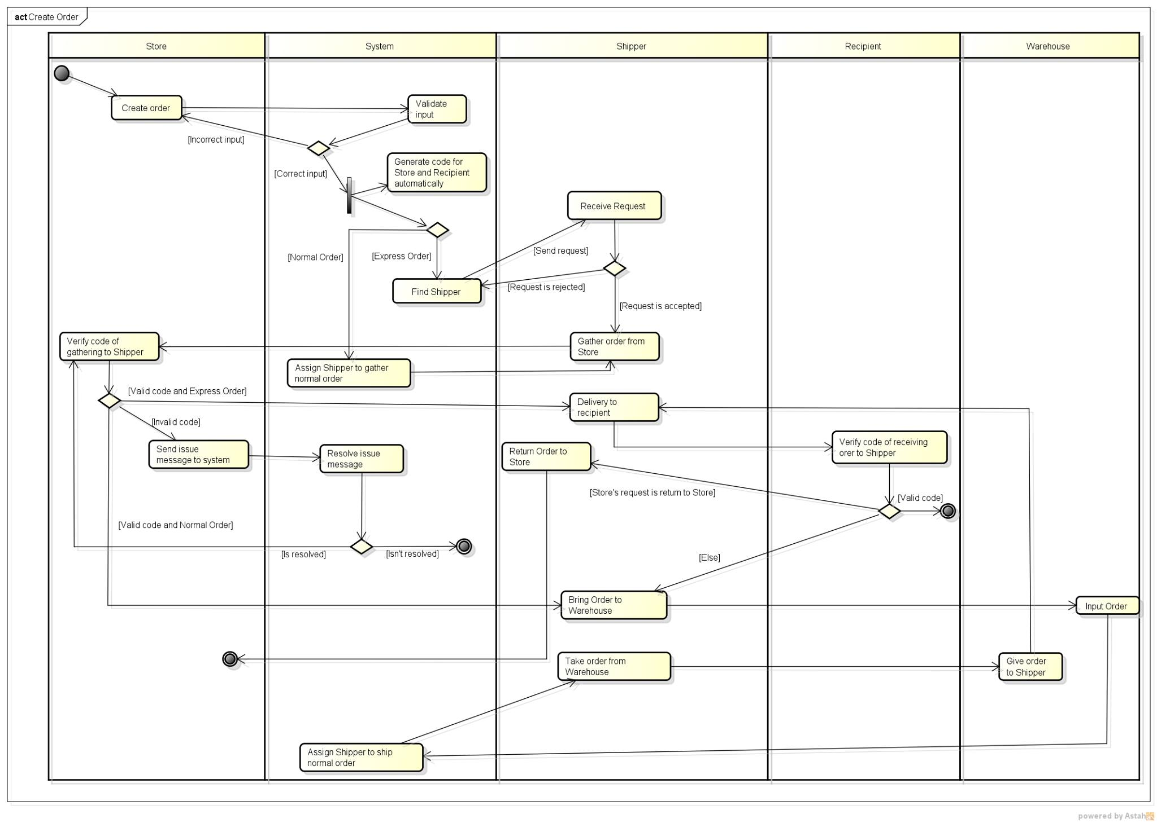

* 1. State Machine Diagram

This diagram describes the status of order:

In case Express Ship:

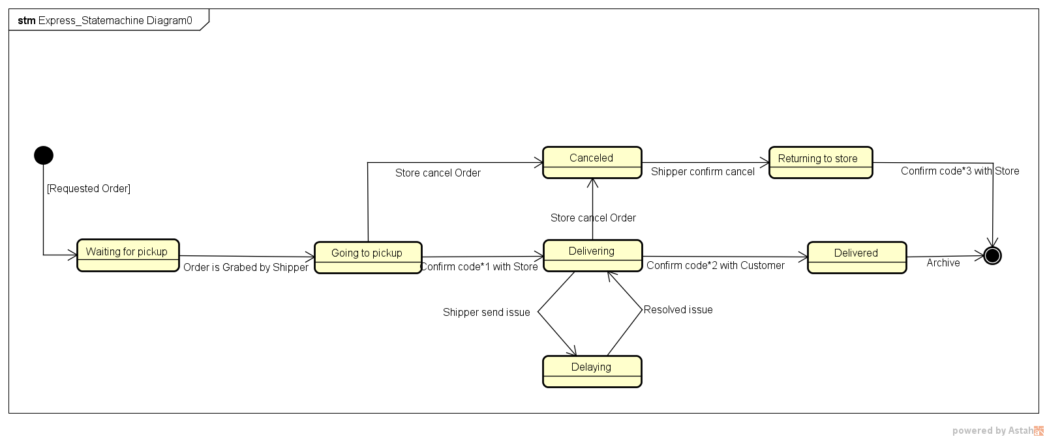

In case Normal Ship:

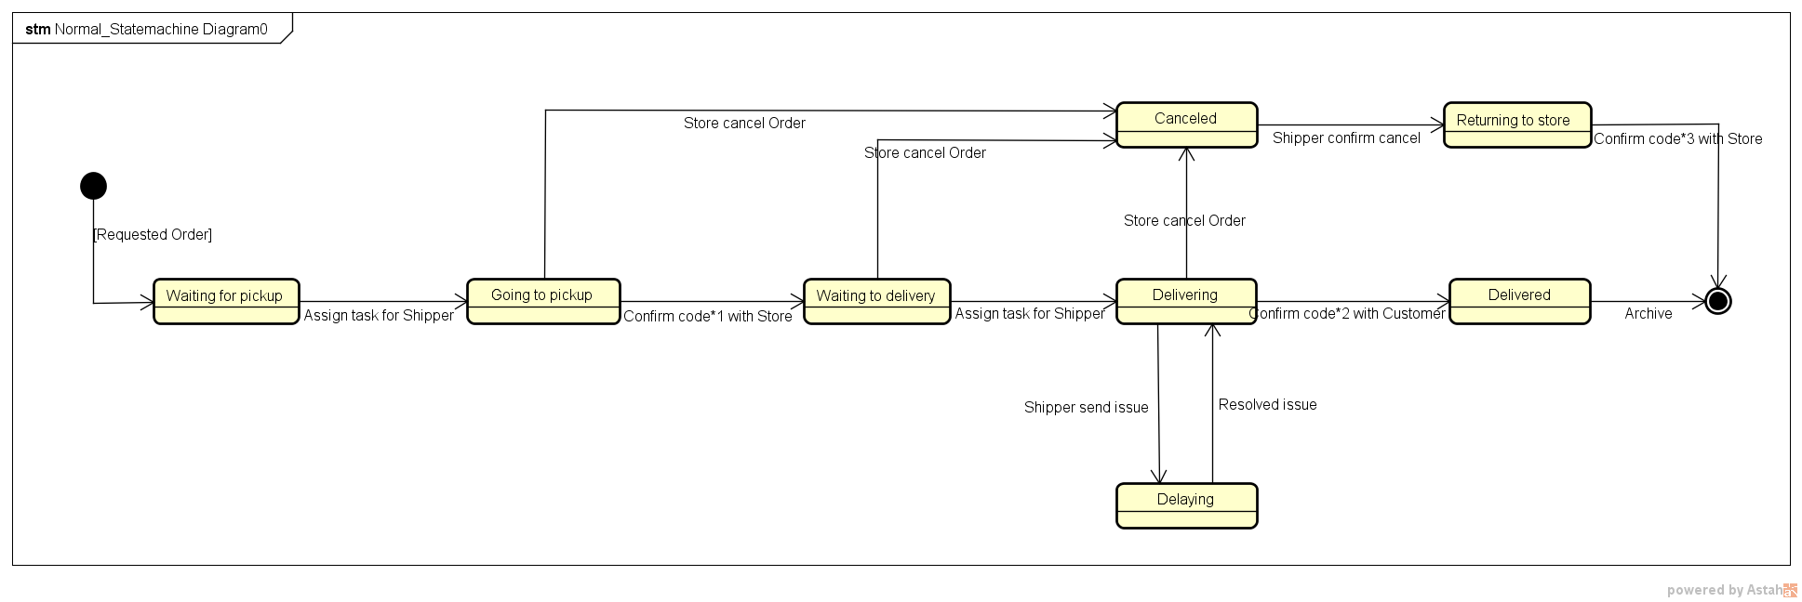

* 1. Entity Relationship Diagram

This diagram describes the relationship among entities of system

